# **Process migrator for WinAutomation (preview) – User guide**

Contents

**Process migrator for WinAutomation (preview) – User guide** 1

**Pre-requisites** 1

**Preparing WinAutomation for processes migration** 1

Process migrator for WinAutomation (preview) 3

**Running the WinAutomation Process Migrator (private preview)** 4

Process migrator for WinAutomation (preview) is a command line tool that transforms automation processes created in WinAutomation to Power Automate desktop flows.

## Pre-requisites

The Process migrator for WinAutomation (preview) require the following to install and run:

* The custom build of Power Automate Desktop (preview) provided with Process migrator for WinAutomation (preview), installed on the same PC.
* Access to Power automate along with an environment with a Dataverse database.

## Preparing WinAutomation for processes migration

* 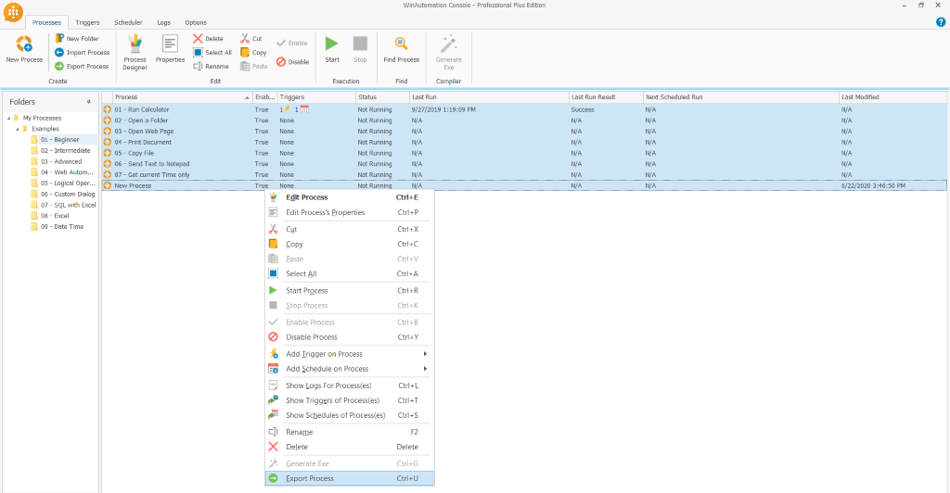In order to be able to migrate your WinAutomation processes to Power Automate desktop flows, you first need to export them by selecting **Export Process** and specify the folder to export the processes into.

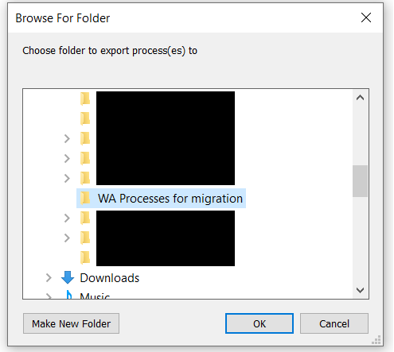   
 

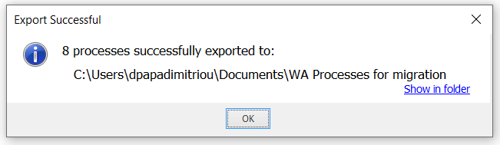

In case you are exporting one or more processes including sensitive data, you will be automatically prompted to specify an encryption password.

**Note:** For processes including sensitive data exported from WinAutomation 9.2 or later a password is automatically required. For older versions, navigate to

**Note:** This password will be required during the execution of the Process migrator for WinAutomation(preview)

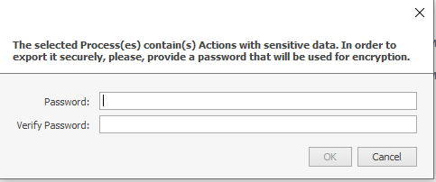

## Installing the Process migrator for WinAutomation (preview)

After successfully downloading the setup file of Process migrator for WinAutomation (preview), select to install it.  Follow the steps of the installer.

**Note**: During the installation while accepting the terms of use, you will be prompted to accept the conditions regarding information shareability with Microsoft. This setting is inherited by the Power Automate Desktop (preview) installation. In order to change it, you would need to reinstall Power Automate Desktop (preview).

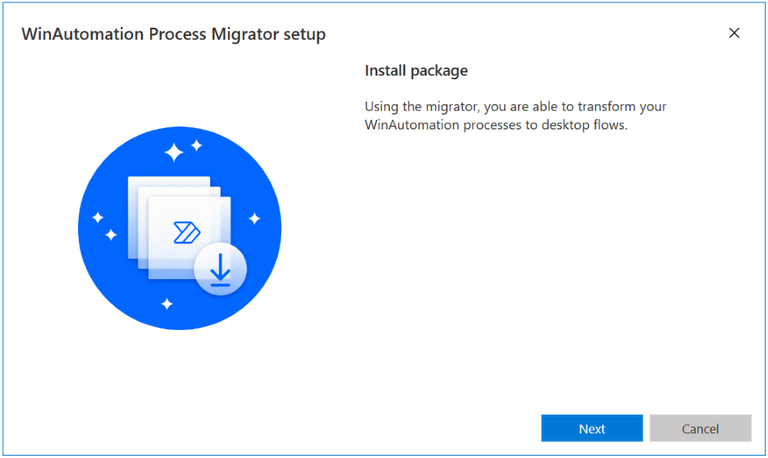

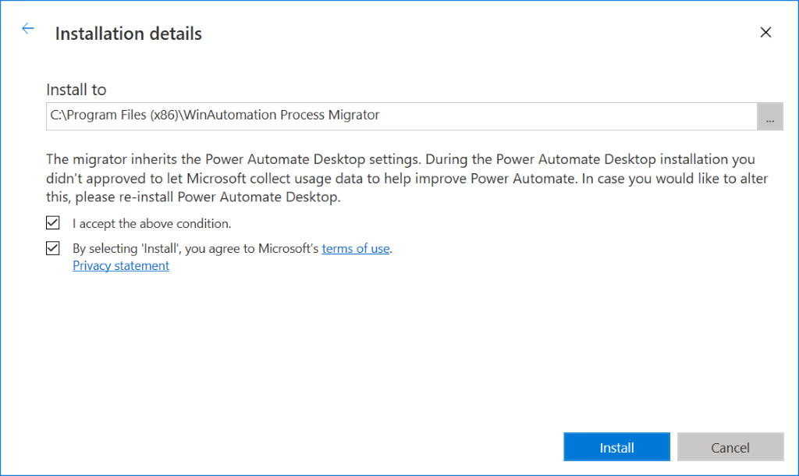

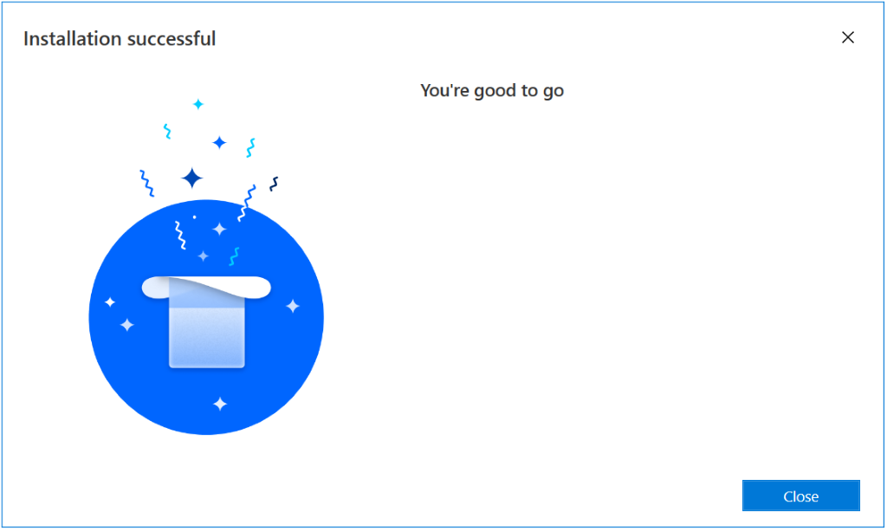

## Running the Process migrator for WinAutomation (preview)

## Once the installation has been successfully completed, navigate to the installation folder (default installation location: “**C:\Program Files (x86)\WinAutomation Process Migrator**”).

* On the navigation bar of the Folder explorer type “**cmd**” to open the command-line prompt in this folder.
* 

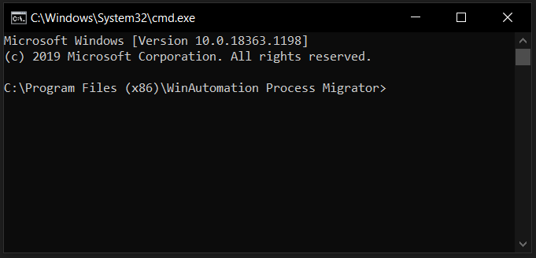   
 

 

* To migrate your WinAutomation processes to uiflows, three arguments are required to be given as an input to Process migrator for WinAutomation (preview)
* **--path:**The folder path where your previously exported processes from WinAutomation are stored.
* **--environment**: The environment were the migrated flows will be stored.
* **--upn:**Your UPN (user email you use to sign-in to Power Automate).
* The command template looks as follows:    
  WinAutomationProcessMigrator --path "**{Path to the folder containing the exported processes}**" --environment "**{Power Automate environment you wish to save the migrated process to}**" --upn **{email used to access your Power Automate account}**
* Replace the {} with valid information
* A sample command looks like this:

WinAutomationProcessMigrator.exe --path "C:\Users\someone\Desktop\My Processes" --environment "Contoso”

--upn [someone@example.com](mailto:someone@example.com)

* You will then be prompted to connect to the account you use to access your Environments in order for the migrated processes to be saved as flows.
* 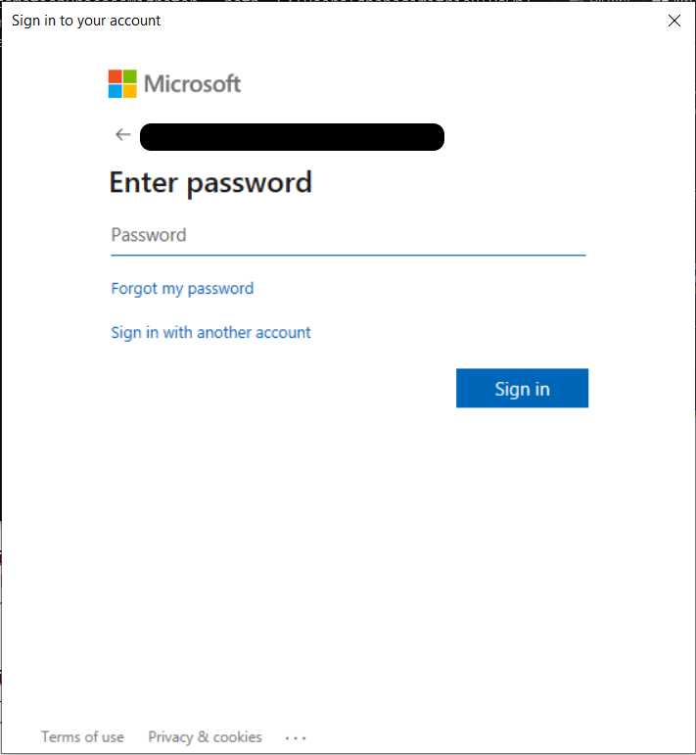
* Each time an encrypted process is migrated, Process migrator for WinAutomation (preview) requires the password used for encryption.

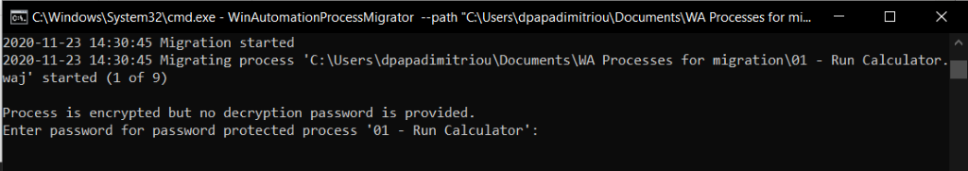

* By clicking **enter** the password will be omitted (and thus omitting to migrate the encrypted process).
* After entering an invalid password for the third time, the migration of the said process will be also omitted
* 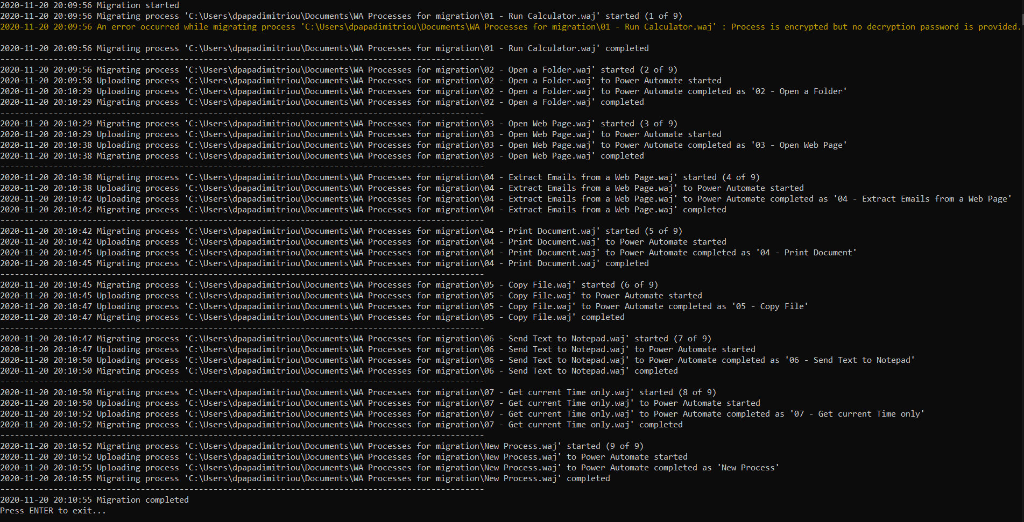
* Once the migration is complete, visit **Power Automate**, navigate to **My flows**and select the **UI flows**option. You can now see the migrated UI flows:   
  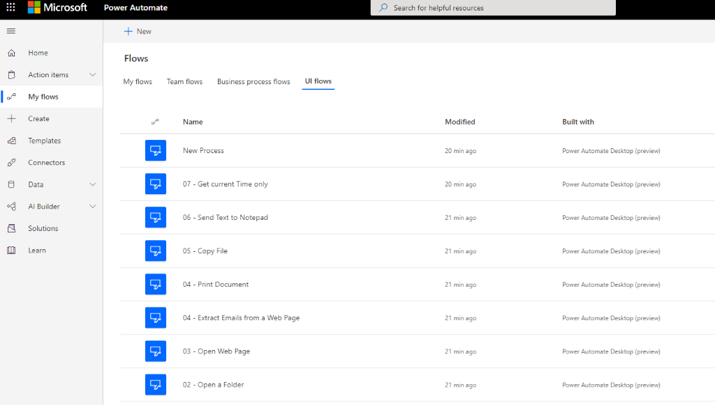
* You can modify the migrated processes (now UI flows) through Power Automate Desktop (preview)

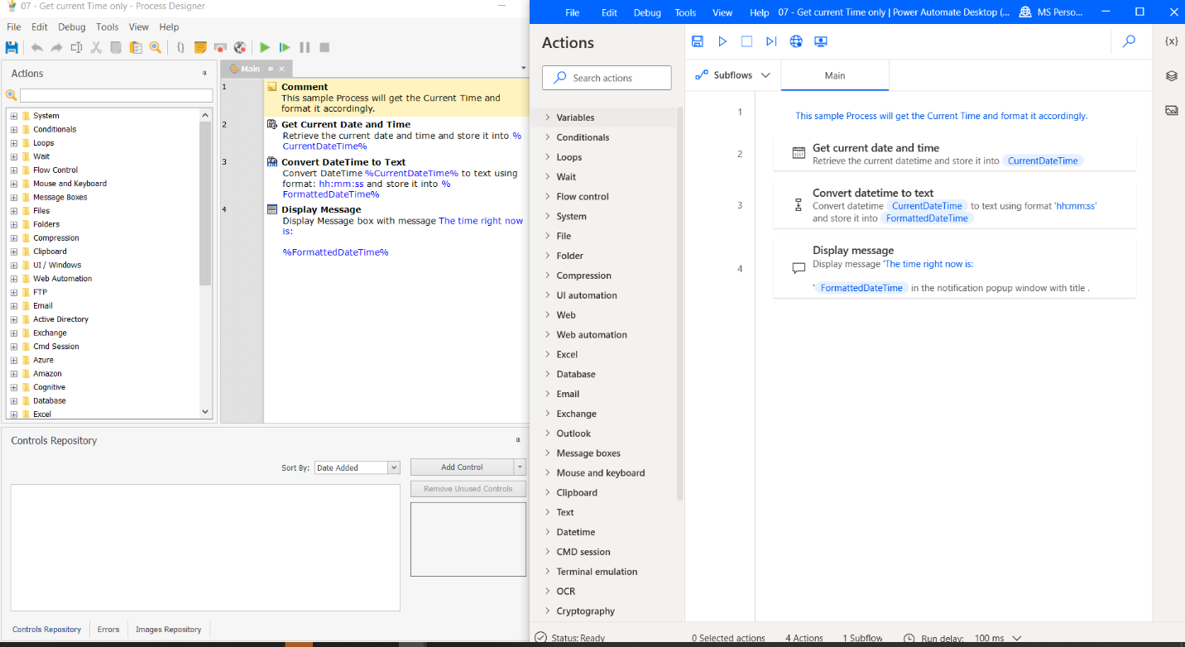1 

* You can access the exported logs from WinAutomation Process Migrator (private preview) at **C:\Users\{username}\AppData\Local\Microsoft\WinAutomation Process Migrator\Logs**    
  to get more information about the migration process execution.    
  (replace {usename} with your user name on the PC you are executing WinAutomation Process Migrator (private preview) )

**Tips**

* Execution of WinAutomation Process Migrator (private preview) will be paused once an encrypted process has been encountered, waiting for the password to be inputted by the user.   
  It is advised to group processes based on whether they are encrypted or not.    
  This way, unencrypted processes will be migrated without requisite supervision during the execution of WinAutomation Process Migrator (private preview) and the encrypted ones will have the requisite user attendance.
* Tip: you can get information about Process migrator for WinAutomation (preview) by typing **--help**/**-h**/**-?** (e.g. **WinAutomationProcessMigrator --help**)

**Screenshot might change**

